BSPD 3P

Three separate boards in accumulator, pedal box and HVD. Main board in HVD monitors outputs from pedalbox and accumulator boards which detail whether the brake of current thresholds have been passed or if there are any open circuit or short circuit implausibility’s.

The two monitor boards have pulldowns on their inputs and buffered outputs. Each board also has led displays to show threshold and OCSC state.

# Pinout Main

* 12 V
* GND
* PRESSURE_THRESHOLD
* PRESSURE_~OCSC
* CURRENT_THRESHOLD
* CURRENT_~OCSC
* BSPD_OK

# Pinout Pressure

* 12 V
* GND
* PRESSURE_THRESHOLD
* PRESSURE_~OCSC
* BPS1_SIG
* BPS1_PWR
* BPS1_GND
* BPS2_SIG
* BPS2_PWR
* BPS2_GND

# Pinout Current

* 12/5 V
* GND
* CURRENT_THRESHOLD
* CURRENT_~OCSC
* CURRENT_SENSE

# Block Diagram

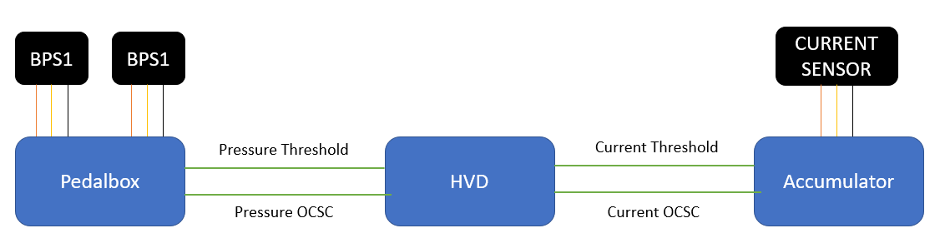

# Compliance

The set of BSPD units function together to fulfil the BSPD rules **EV 8.7**.

# Component ICs

## Main

|  |  |  |
| --- | --- | --- |
| **Component** | **Footprint** | **Quantity** |
| AO3401A PMOS | SOT-23 | 1 |
| LM1117-5 | SOT-223-3 | 1 |
| QUAD AND MC74HCT08 | SOIC 14 | 1 |
| SINGLE OR | SOT-23-5 | 1 |
| MCP6002 | SOIC 8 | 1 |

## Pressure

|  |  |  |
| --- | --- | --- |
| **Component** | **Footprint** | **Quantity** |
| AO3401A PMOS | SOT-23 | 1 |
| LM1117-5 | SOT-223-3 | 1 |
| LM393 | SOIC 8 | 3 |
| MCP6002 | SOIC 8 | 1 |

## Current

|  |  |  |
| --- | --- | --- |
| **Component** | **Footprint** | **Quantity** |
| AO3401A PMOS | SOT-23 | 1 |
| LM1117-5 | SOT-223-3 | 1 |
| LM393 | SOIC 8 | 2 |
| MCP6002 | SOIC 8 | 1 |